**Assignment-1**

**Setup Private git Server**

**Group members**

**Abhilash(18MCMB16)**

**G Hareesh (18MCMB15)**

**1st question:**

1. **Create a Project repository**

Make the new directory and add some files to it .on command line type

**git init**: this command will creates an empty git repository

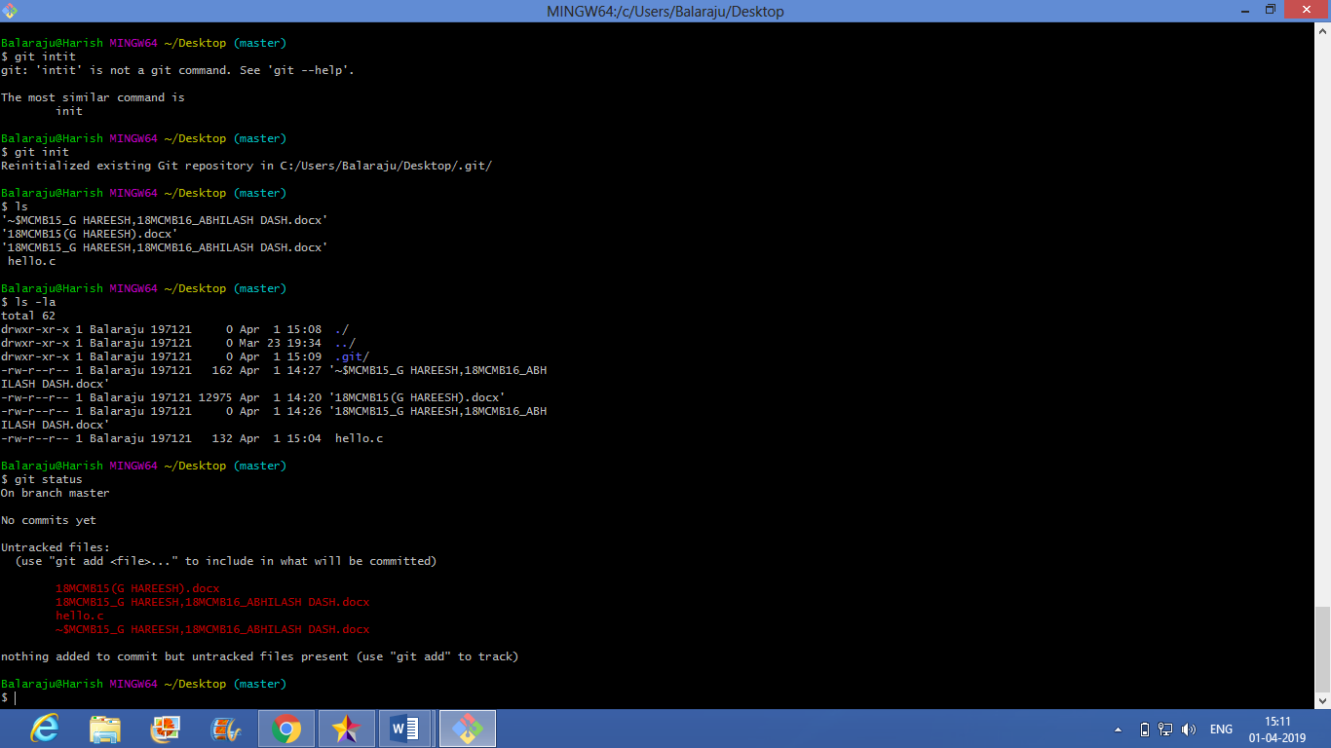

Their are untracked files so for that we need to type :

**git add –A**: add files to the index

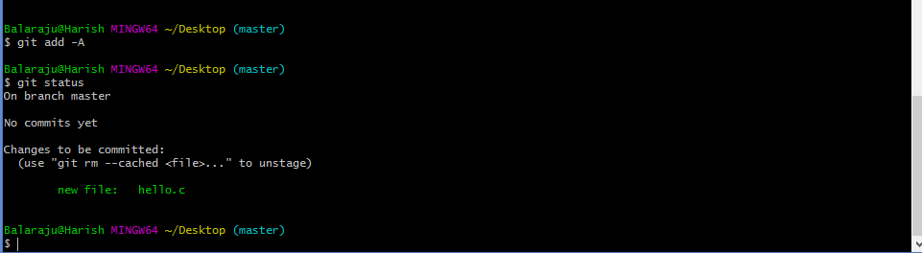

**git status:** showing the working tree status

1. **connect it to git hub**

Go to github

Log in to your account.

Click the new repository button in the top-right. You’ll have an option there to initialize the repository with a README file, ,for my case “new repository”

Click the “Create repository” button.

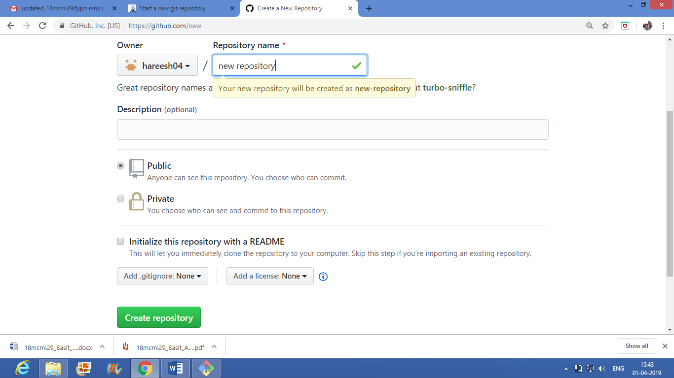

**git commit –m “message”:** Record changes to the repository

1. **push an existing repository from the command line**

**git remote add origin** [**https://github.com/hareesh04/new-repository.git**](https://github.com/hareesh04/new-repository.git)

**git push -u origin master**: we ready to push the our first comment to the repository

Finally at last repository is reflected into github account

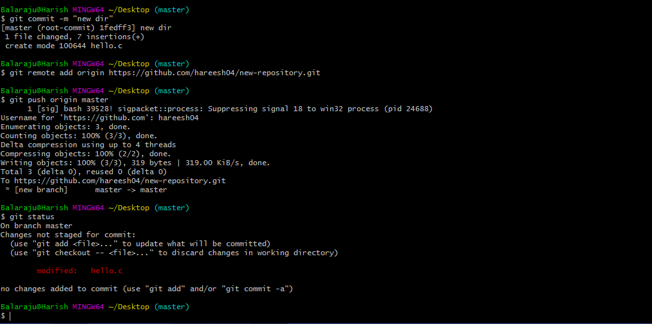

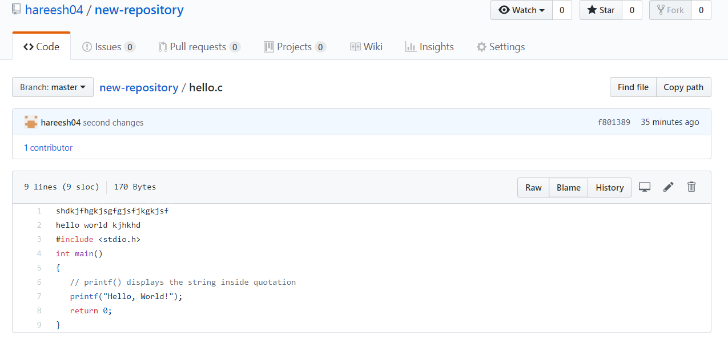

**2nd question**: create a branch for the different functions you want to update

To create branch locally as long as you have a cloned version of the repository.

1. From your terminal window, list the branches on your repository.

Using command: git branch

2. Create a new feature branch in the repository

Using command: git branch <feature branch>

1. Switch to the feature branch to work on it.

Using command: git checkout <feature branch>

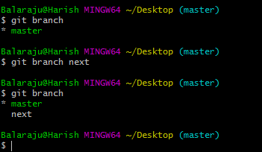

**git checkout next:** To create branch name as next for changing the function next (switched to branch next)

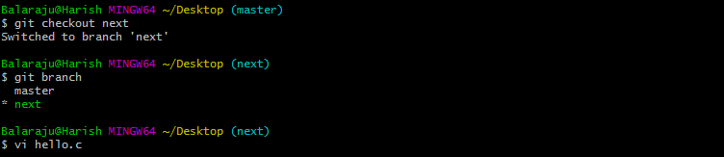

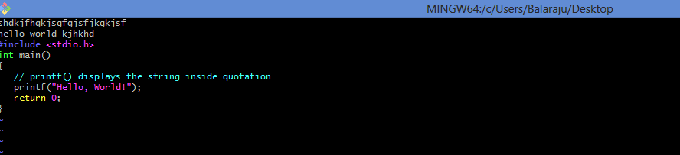

Update the function next in hello.c

Now again repeated the previous steps

1 git status

2 git add –A

3 git status

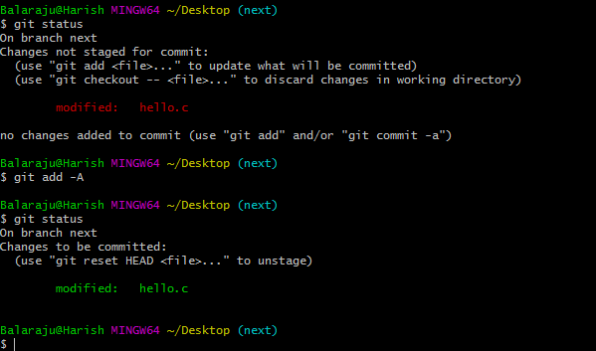

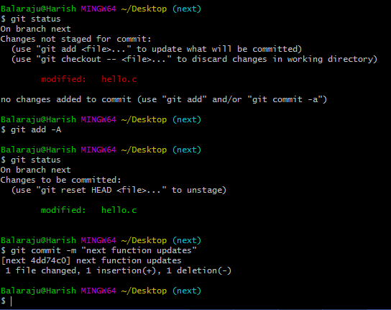

git push –u origin next: both git pull and git push done

